INSTRUCTIONS and HANDOVER NOTES

Overall System diagram
WIFI ROUTER

TEAM RED BOT(S)
TEAM BLUE BOT(S)
TEAM RED BASE
FLAG
JUDGES COMPUTER
TEAM BLUE BASE
CAPTURE POINTS AND FLAG
Each point has an Arduino, Wifi shield, RFID Reader and RGB LED. The capture points and flag communicates to the Judges computer through the Wifi router. The Judges computer tells the points what to do and the capture points relay the RFID card information (Card attached to the team’s bot) to the Judges computer.

JUDGES COMPUTER
A Processing program that provides a GUI between the Judge and capture points. The program tells the Capture Points what to do. Such as the LED colour when the round starts, when a team has captured the flag and when the round is complete. The GUI program also keeps score and real time status of the flag. The program can currently handle 4 bots per team. Any more will require further adjustment to the program.

TEAM BOTS
This part hasn’t been developed yet at the time of writing this. Unsure how the bots will be controlled and what bots they will be using. Whatever the outcome each team will be required to attach an RFID card to the bottom of each of their bots. The RFID card is the identifier for each bot. So if there were 4 bots per team; the blue team RFID cards would read “1,blue”; “2,blue”; “3,blue” and “4,blue”. Red team bots would read “1,red”; “2,red”; “3,red” and “4,red”.

GETTING STARTED

- Open processing 3 and open the Capture the flag sketch.
- Turn on router and connect the judge’s computer.
- Turn on each of the capture points. The LEDs will be a solid yellow.
- Press play on the Processing IDE and the below screen will appear

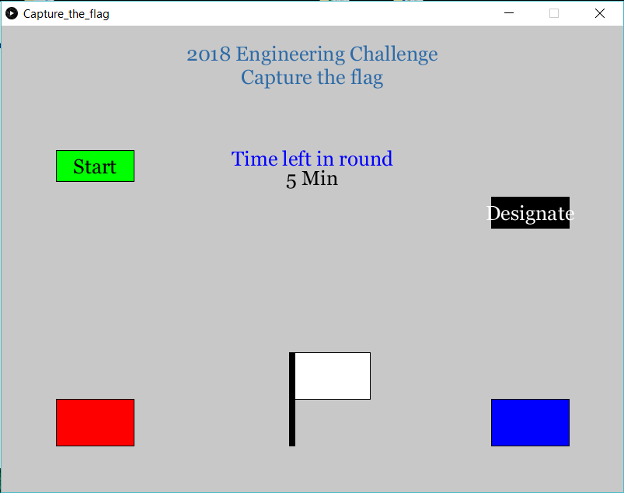

- Press the Designate button. Each capture point will now flash the colour of its designated role. White for flag, blue for blue base and red for red base.
- When teams are ready to begin press the start button. On the GUI a reset button will appear and the round timer will begin to countdown. The flag capture point LED will now be solid on and the base LEDs will be off.
- When a team bot drives over the flag and the RFID registers, the GUI will start a 30 sec timer and the flag will flash the capturing teams colour. The opposing teams colour will appear in the centre of the GUI with the word Defend. The flag capture point will now be off and their base will be flashing.
- If the opposing team successfully defends and the 30 secs expires then the flag is reset to the centre and open for capture by either team again.
- If a team successfully captures the flag then the GUI will display the round as complete and clearly display the winner.
- For another round press reset and then designate again.
- If no team captures the flag before the round timer gets to zero then the round is declared as a draw.

Additional information and troubleshooting

The designate button tells each of the Capture points that it is Capture the Flag and it tells each of them what they are. Eg Flag, Blue base or Red base. Each capture point will have its own IP address which is how we talk to each one individually through UDP. If a base is indicating a yellow LED then it hasn’t been designated a role and a communication error has occurred. Check the DIP switches on the WiFi shield are set to ON. Next check that the IP address is correct in processing. If still no luck look through the How to flash a Wifi module for more information about accessing the Wifi shield settings. If it’s not any of the above or a simple wiring issue then it may be a hardware issue. Have a backup ready to go.

Teams need to be told that for the RFID to register on the capture points they need to be accurate and give it time to register. Just driving flat out over the top won’t necessarily capture the point. At the time of writing this, you will need to get more RFID cards. Ensure they are Mifare and I would get the larger credit card size ones so teams don’t need to be so accurate over the capture points. In trials I was using the smaller tags that come with the duinotech RFID reader/writer as I didn’t know where the cards were. Can get lots of cheap ones on ebay.

In the processing program under the “Setup” tab is where you can change IP addresses or the round and capture timers. Also as a judge if you want to just get a feel for the GUI, go to the “Capture_the_flag” tab and within the void loop uncomment the testButtons function. When you press start a couple of extra buttons will appear where you can simulate captures etc.

Another way to test the system is to download a UDP send/receive app on your smart phone (I use UDP terminal). Connect your phone and computer to the same access point and set the IP and Port the same as the flag IP then broadcast a 1 to an 8 and you should see the program work the same it would with the capture points on. Having 3 smart phones going with this at once you can simulate each of the capture points by setting each phone with the capture point IP addresses. This will ultimately test the system without having to setup actual capture points. If the phone designated as the flag sends a 1 then the Processing sees that as blue car 1 has the flag. Then if the person designated as blue base sends a 1 then the program will see that as a full capture. No other “car” (2 to 8) should be able to get the full capture unless they were the one to get the flag in the first place. See table in how to set up RFID’s as to how the system is set up to communicate.

ARDUINO LIBRARIES NEEDED
- #include <SPI.h> //include the SPI bus library
- #include <MFRC522.h> //include the RFID reader library

HOW TO SET UP YOUR RFID’S

Note: If your WiFi shield is attached ensure the DIP Switches are off. I would personally just set up a totally separate Arduino and RFID read/writer. Should be the same pins as shown in the pinouts document.

- Open Arduino IDE and connect the USB cable to the Arduino.
- Open the RFID Write sketch.
- Within the “RFID_Write” tab look down about half way and find a line that states something similar to this;

byte blockcontent[16] = {1,2,'A',1,0,0,0,0,0,0,0,0,0,0,0,0};//all zeros. This can be used to delete a block.

- Change this to {1,’,’,'b',’l’,’u’,’e’,0,0,0,0,0,0,0,0,0,0}
- Upload this to the Arduino
- Open up serial monitor
- Take the RFID Card you want to upload to and hold it next to the RFID read/writer
- The Serial monitor should come back with the ASCII equivalent as shown;

card selected
2 is a data block:
block was written
block was read
read block: 1 44 98 108 117 101 0 0 0 0 0 0 0 0 0 0

- That RFID now reads as a string 1,blue
- Repeat steps 4 to 8 for all RFID cards required. We want each card to be unique the coding for the capture points allows 4 cars per team as shown below.

Blue Team
RFID Card reads: | WiFi communicates it via UDP as:
1,blue | 1
2,blue | 2
3,blue | 3
4,blue | 4

Red Team
RFID Card reads: | WiFi communicates it via UDP as:
1,red | 5
2,red | 6
3,red | 7
4,red | 8

HOW TO FLASH A WIFI MODULE

If and when you get a new Wifi shield this particular module requires to be flashed before you can use it. Their might be easier modules out there now, but this is the one I used at the time and once it is flashed it is easy to use. It’s as simple as Serial.print(); and that data is broadcast out on that IP without the need for additional libraries. Below is something I found that works a treat, you will need the USB to Serial Adapter module (Jaycar P/N: XC4464).

Programs and firmware are provided on a USB if not google is your friend (See https://github.com/nodemcu/nodemcu-flasher);

- Doit firmware – “ESP8266_Doit_ser2net(v2.4.1).bin”
- ESP Flasher program - ESP8266Flasher.exe

XC4614 as Arduino Board using XC4464 or XC4414 as programmer
Thanks to the Arduino community, we can now use the powerful processor on the XC4614 as its own Arduino board. Bear in mind that the ESP13 chip on this board is only rated for 3.3V, and may be damaged if exposed to 5V signals.

Installing Arduino support for the Board

Make sure you are using Arduino 1.6.4 or later (I’ve got this working with Arduino 1.6.7).

Info for the Arduino Support Package can be found at:
https://github.com/esp8266/Arduino

TO install board support for ESP8266 (wifi Shield):
In File>Preferences>Additional Board Manager URLS add:

http://arduino.esp8266.com/stable/package_esp8266com_index.json

separating from existing entries with a comma.

Go to Tools>Boards>Boards Manager and type 'esp' in the search box- install ESP8266 by ESP8266 Community (this is about 150MB download and can take a while).

Choose ESP8266 from Boards, and check that the other default settings are as follows (these should be the defaults, except the Flash Size is 4M):

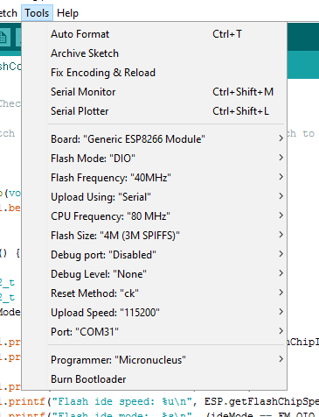

The Port that you use may be different, and corresponds to the COM port used by the XC4464 or XC4414.

Wiring it up:

To XC4464:
You will need WC6028 (plug to socket jumpers). Ensure that the voltage switch on the XC4464 is set to 3V3, as the ESP13 chip is only rated to 3.3V. Make the following connections:

XC4614 (Wifi Shield) | XC4464 (FTDI Board) | Function
5V (on Arduino side) | 5V | Power (there is a 3.3V regulator on the board)
G (on Arduino side) | GND | Ground
RX0 (on ESP13 side) | TXD | Data from XC4614
TX0 (on ESP13 side) | RXD | Data to XC4614
D0 (on ESP13 side) | No connection | Programming selector

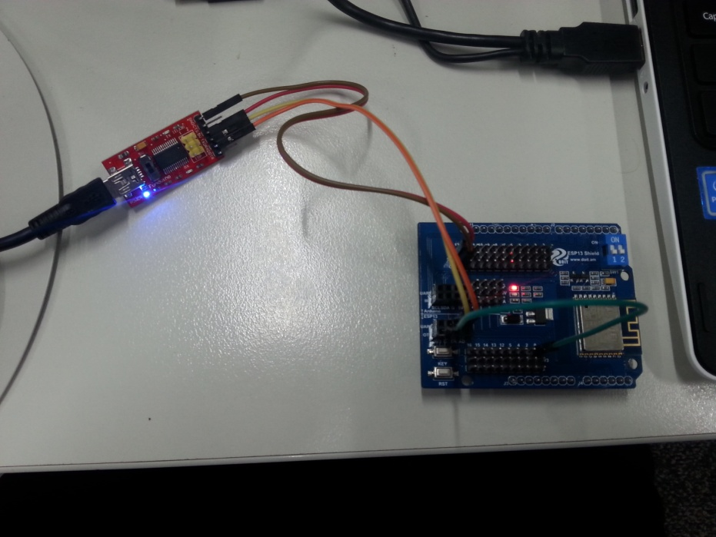
During the programming phase, the wire on D0 is connected to GND (G) on the shield (see green wire in picture above). This tells the shield to enter programming mode next time it is reset.

To Nano (XC4414):
If you’re using a Nano, make sure it has a sketch that doesn’t use the Serial port at all (the easiest way is to select File>New, and upload the empty sketch to the board). We’re just using the USB-Serial converter on the board, so the sketch doesn’t need to do anything.
XC4614 (Wifi Shield) | XC4414 (Nano) | Function
5V (on Arduino side) | 5V | Power (there is a 3.3V regulator on the board)
G (on Arduino side) | GND | Ground
RX (on Arduino side) | TX1 | Data from Nano board
TX (on Arduino side) | RX0 | Data to Nano board
D0 (on ESP13 side) | No connection | Programming selector- goes to G on XC4614

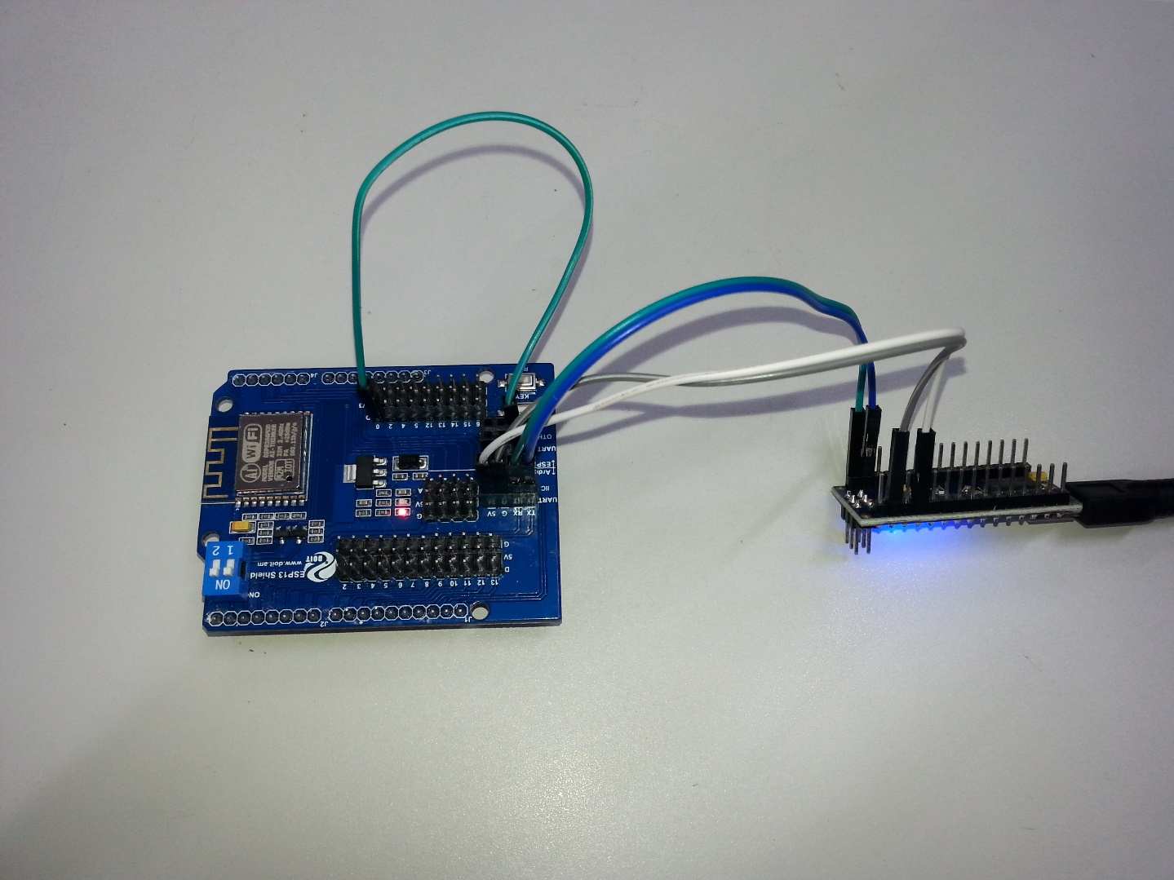
During the programming phase, the wire on D0 is connected to GND (G) on the shield (see green wire in picture above). This tells the shield to enter programming mode next time it is reset.

During normal operation, the green wire is not needed. If serial communication is not needed, then the orange and yellow wires will not be needed either. There are many example sketches- see File>Examples(Examples from Custom Libraries)>ESP8266WebServer>HelloServer for a basic web server to test that everything works as it should. Remember to change the Wifi network name and password to match yours.
The sequence to upload should be:
1. Connect green wire to GND.
2. Plug XC4464 into computer. (for subsequent uploads, press RST on module)
3. Select upload.
4. After a successful upload, the sketch will start automatically, so you don’t need to remove the green wire until you have finished tweaking your sketch. Go back to step 2 if you still need to upload another version.

Writing a Sketch:
See https://github.com/esp8266/Arduino/blob/master/doc/reference.md and https://github.com/esp8266/Arduino/blob/master/doc/libraries.md

You might also look at enabling OTA (over the air, or Wifi) programming. See https://github.com/esp8266/Arduino/blob/master/doc/ota_updates/readme.md for examples.

FLASHING THE WIFI MODULE

- Open up the NodeMCU firmware programmer

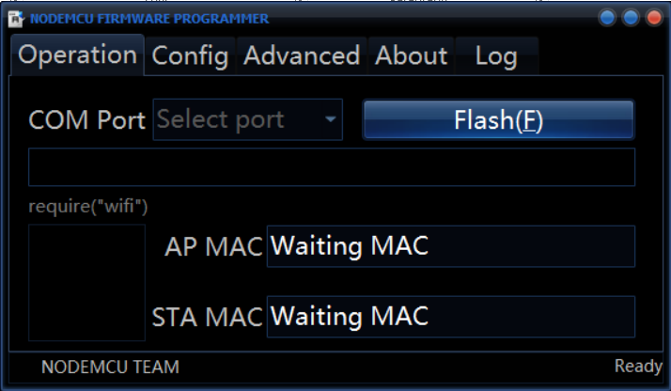

- You should have the MAC addresses auto-filled if you are communicating to the shield correctly.
- Open config and copy the file location of the Doit firmware.

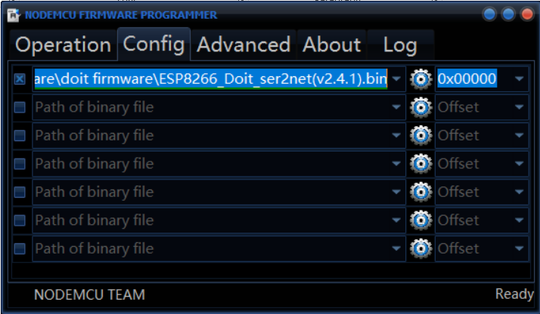

- I didn’t need to touch the advanced section
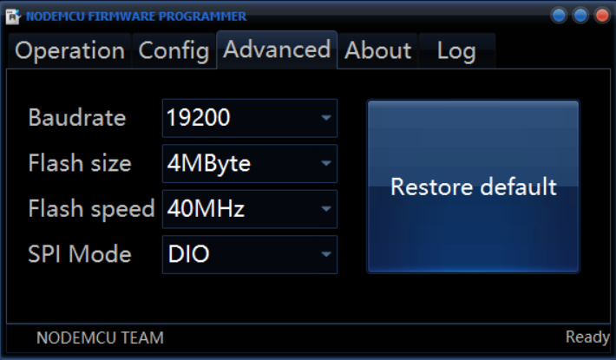

- Go back to the operation screen, check your port is correct (shouldn’t be communicating if incorrect) should be able to find it in windows device manager.
- Press flash and should be complete in a few seconds.

ACCESSING THE SETTINGS OF THE WIFI MODULE

- Power up wifi module
- Connect to it like you would any other access point (should be open)
- Open internet explorer and type in the IP address 192.168.4.1 into the address bar the below should open up.

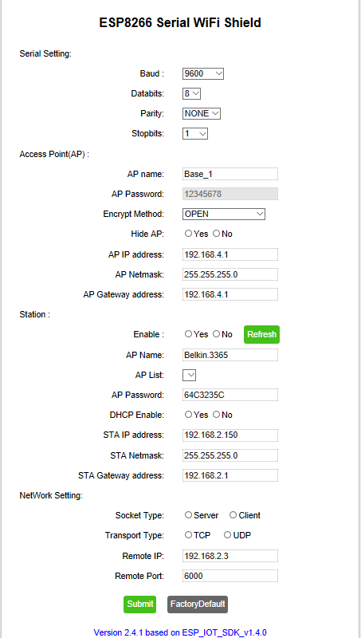

- This is an example of one of the wifi modules used for the Engineering Challenge currently. So as a capture point it automatically connects to router Belkin.3365 using password 64C3235C and has a static IP as 192.168.2.150.

